**Ventura County**

**Security and**

**Emergency Action Plan**

**Department:** Click here to enter text.

**Location(s):** Click here to enter text.



**Ventura County Employee**

**Security and Emergency Action Plan Template**

Revised 2023



**Courtesy of:**

General Services Agency   
Facilities and Materials

Security and Special Services

**CONFIDENTIALITY STATEMENT**

The contents of this document are confidential, and they should only be shared with individuals possessing a legitimate need to know them. This document has been prepared in an effort to provide for the safety and security of County employees and facilities. The possession of this document by unauthorized persons could compromise workplace security and therefore the safety of our employees.

**CONTENTS**

Purpose 4

Points of Contact 6

Emergency Notification Procedures 6

Emergency Communications 6-7

Building Emergencies/Evacuations 8-9

Earthquake Procedures 10-12

Hazardous Materials/Gas Leak/Steam Line 12-13

Workplace Security/Education, Training, Awareness 14-15

Personnel Requirements 16-17

Physical Security 17-20

Response to Violence 21-28

Active Threat/Shooter 21-22

Bomb Threat/Suspicious Package/Mail/Activity/Persons 24-27

Office Security 28-29

Appendices

Appendix A

Designation of Staff/Evaluation Roles

Emergency Assembly Area/Tally

Evacuation Evaluation

Appendix B

Evacuation Guidelines for people with disabilities

Appendix C

Evacuation/Assembly area maps

Appendix D

Additional Department/site specific information

**PURPOSE/INSTRUCTIONS**

The purpose of this document is to provide guidance to agencies, departments and individuals for developing a workplace security and building emergency response planning document. A completed site specific plan will provide employees, visitors, patrons and contractors with a more secure working environment through proactive implementation of security measures. It is designed to not only protect people but assets and operations as well against threats of injury and loss or damage by criminal, hostile or malicious acts.

***Contact GSA, Special Services Division to obtain assistance in development of evacuation diagrams and Emergency Assembly Area (EAA). The division can be reached at (805)654-3721.***

**To complete the document, provide the requested information in the form’s fillable areas. Send a completed copy of your Security Emergency Action Plan (SEAP) to GSA Special Services Division, Locator #3030 or email it to** [**james.dollar@ventura.org**](mailto:james.dollar@ventura.org) **or** [**sean.payne@ventura.org**](mailto:sean.payne@ventura.org)**. The document should be reviewed and updated annually.**

Below are names and telephone numbers of contact who may be used as resources for customizing your template.

**Topic Phone Number Department**

Building Coordinator Program 654-3816 GSA Special Services

Preparedness Outreach

Building Floor Plans 654-3878 GSA Maintenance

County Emergency Planning 654-3721 GSA Special Services

Emergency Response Plans 662-6538 CEO Risk Management

Fire Extinguisher Use 662-6538 CEO Risk Management

Fire Prevention 654-3721 GSA Special Services

**Evacuation maps and assembly area maps should be added as Appendix C. Each department and building committee should review the evacuation routes and assembly areas to ensure that they are accessible to all persons. Maps may be inserted into the fillable areas.**

**Site specific emergency and/or security information should be added as Appendix D. The additional information can be added in the fillable**

**POINTS OF CONTACT**

Security Control Center 805-654-2931 and 805-654-2345

Security Operations Manager 805-654-3816

Security Division Manager 805-654-3721

Security Services Manager 805-650-4079

Maintenance Dispatch 805-654-3878

Human Resources 805-654-5129

Industrial Relations 805-654-3196

Employee Assistance 805-654-4327

Public Health 805-981-5010

Environmental Health & Safety 805-6542813

HMAP (HazMat Service) 805-654-3197

**Links to Safety and Evacuation Posters**

**Earthquake Safety** <https://www.redcross.org/content/dam/redcross/get-help/pdfs/earthquake/EN_Earthquake-Preparedness-Checklist.pdf>

**Bomb Checklist** <https://www.cisa.gov/resources-tools/resources/dhs-bomb-threat-checklist>

**Bomb Threat Stand-Off Card** <https://www.cisa.gov/sites/default/files/2022-11/Bomb%20Threat%20Stand-off%20Card%20Digital%20Final%20v2.0.pdf>

**Suspicious or Unattended** <https://www.cisa.gov/resources-tools/resources/unattended-vs-suspicious-item-postcard-and-poster#:~:text=A%20suspicious%20item%20is%20anything,equipment%20to%20further%20evaluate%20it>.

**Suspicious Mail or Packages** <https://about.usps.com/posters/pos84.pdf>

**EMERGENCY NOTIFICATION PROCEDURES**

In the event of a life safety emergency call 911. When calling 911 (or any other emergency number) from a County of Ventura location to request emergency assistance, make sure to call from a safe location and remember to do the following:

* Stay calm
* Be prepared to answer the following questions:
* Where is the emergency located?
* What is the emergency? (Fire, medical, hazardous material, etc.)
* How did it happen?
* When did it happen?
* Who are you? (Your name)
* Description of anyone involved.
* Gather any other information that may be useful for the emergency responders (are there any injuries involved?)
* Do not hang up until instructed to do so by the dispatcher. Give a telephone number or safe location where the emergency responders can call or meet you and wait for the responders at that safe location.
* It is not necessary to have all the answers to these questions, but quickly gather as much information as you can.

**EMERGENCY COMMUNICATIONS**

The Administrative Manual, Policy No. Chapter IV (B) – 1, entitled “COMMUNICATION ON SIGNIFICANT EVENTS” states that “When a significant unforeseen event or an emergency situation occurs, the lead County agency or department must immediately inform the County Executive Officer and each member of the Board of Supervisors in addition to all other entities that must be informed based on the nature of the emergency.”

Within the Work Unit

The ability to communicate emergency information in a single building or work area within a building is crucial. Having one communication method may not be enough. Using multiple methods increases the chances of getting the message to a larger number of employees. The messages distributed should be clear and concise. Sample messages for evacuation and shelter in place can be written in advance.

You are a part of the inter-departmental employee callback tree per Administrative Manual Policy No. Chapter IV (B) – 9 entitled “EMERGENCY CALLBACK LIST”.

***(*** Click here to enter text.And Click here to enter text.***)*** are the primary and secondary points of   
contact to initiate the emergency callback tree.

* The employee who knows about the danger shall notify the primary contact person AFTER calling 911. That contact person shall call a prearranged list of persons who would each call a short list of individuals different from the first list. They in turn would call another list of individuals until all employees have been notified.
* Where danger is imminent, yell for help or to alert coworkers to evacuate or seek shelter in place.
* Other methods for emergency communications within the department include:
* E-mail lists
* Text messaging
* Intercom or paging systems
* Faxes
* Group call activation
* Handheld radios

Emergency Alert System Information FM-AM Dial Numbers

KVTA Radio Station 1590 AM

KHAY Radio Station 100.7 FM

KMLA Radio Station (Spanish) 103.7 FM

**BUILDING EMERGENCIES**

**General Evacuation Procedures (All employees and building occupants should be aware of how to safely evacuate in the event of an emergency. (See Appendix A for additional information regarding evacuation guidelines for people with disabilities).**

**When evacuating a building or work area:**

* Stay calm, do not rush and do not panic.

• Immediately stop your work.

* Gather your personal belongings if it is safe to do so. (Reminder: Be sure to take prescription medications out with you if at all possible. It may be hours before you are allowed back in the building).
* If safe, close your office door and window, but do not lock them.
* If safe, use the nearest stairwell and proceed to the nearest exit. **Do not use the elevator.**
* Proceed to your designated Emergency Assembly Area (EAA) and report to your Assembly Area Coordinator.
* Wait for any instructions from emergency responders.
* Do not re-enter the building or work area until you have been instructed to do so by the emergency responders

Emergency Information Locations

Posted evacuation diagrams Base of stairways, elevator

(including routes and fire alarm pull stations) landings and inside public doors

Emergency Assembly Area (EAA) Location:

A building occupant is required by law to evacuate the building when a fire alarm sounds. A copy of the EAA is attached as Appendix *

If there is a fire in your work area:

* Activate the fire alarm system by pulling the nearest pull station to notify the buildings occupants. Then (from a safe distance) call 911. Provide details of the situation (see “Emergency Notification Procedures”).
* If you have been trained in the use of a portable fire extinguisher and are safely able to extinguish the fire, you may do so. Be sure you have a safe exit from the area and leave if one extinguisher does not put out the fire.
* Evacuate the building as soon as the alarm sounds and proceed to the designated EAA (see "General Evacuation Procedures").
* On your way out, warn others nearby.
* Move away from fire and smoke. Close doors and windows if time permits.
* Touch closed doors with the back of your hand to feel temperature. Do not open if they are hot.
* Use stairs only. **Do not use elevators.**
* Move well away from the building and go directly towards your designated EAA.

Do not re-enter the building or work area until you have been instructed that it is safe to do so by the emergency responders.

The Building Coordinator should work with the Ventura County Fire Department, Fire Marshal to ensure that there is no excess accumulation of flammable and combustible materials in this building.

The Building Coordinator also works with GSA Maintenance to ensure fire extinguishers, fire alarm systems and fire sprinkler systems in this building are maintained and kept in good working condition.

**Earthquake Procedures**

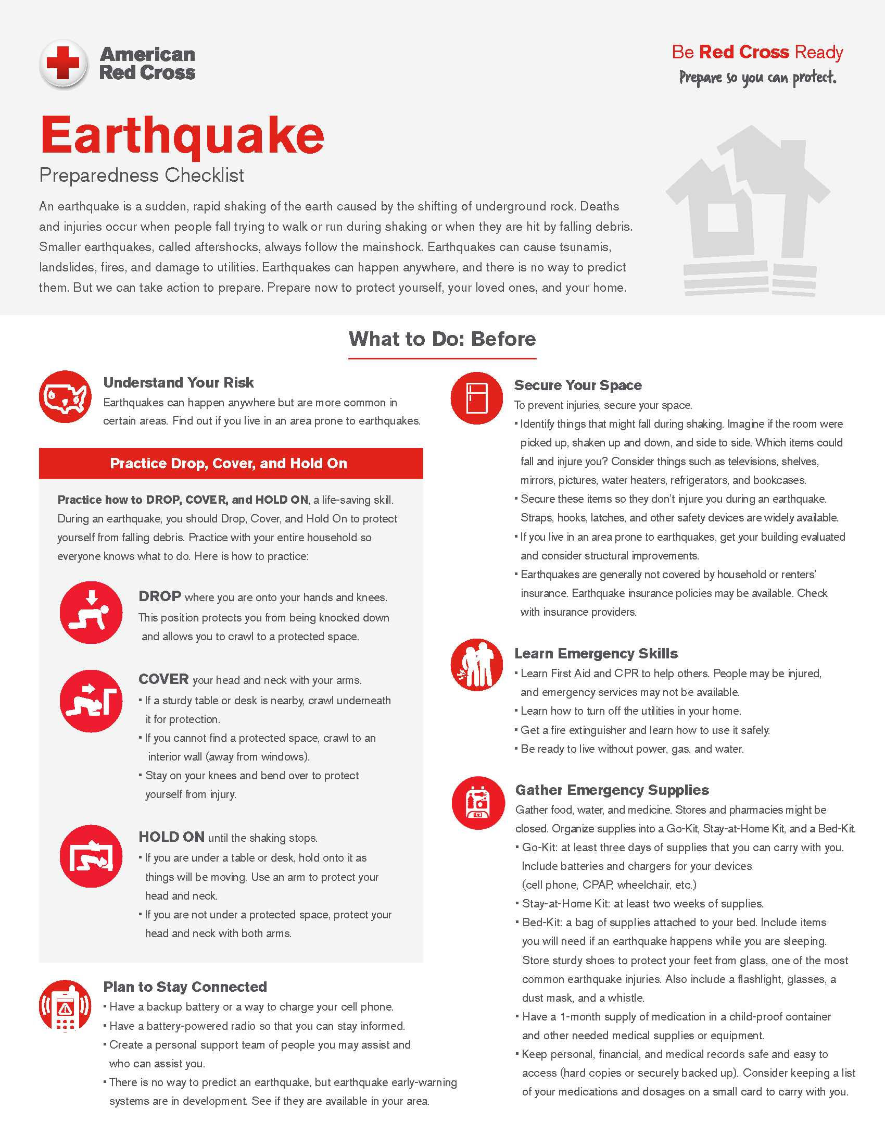

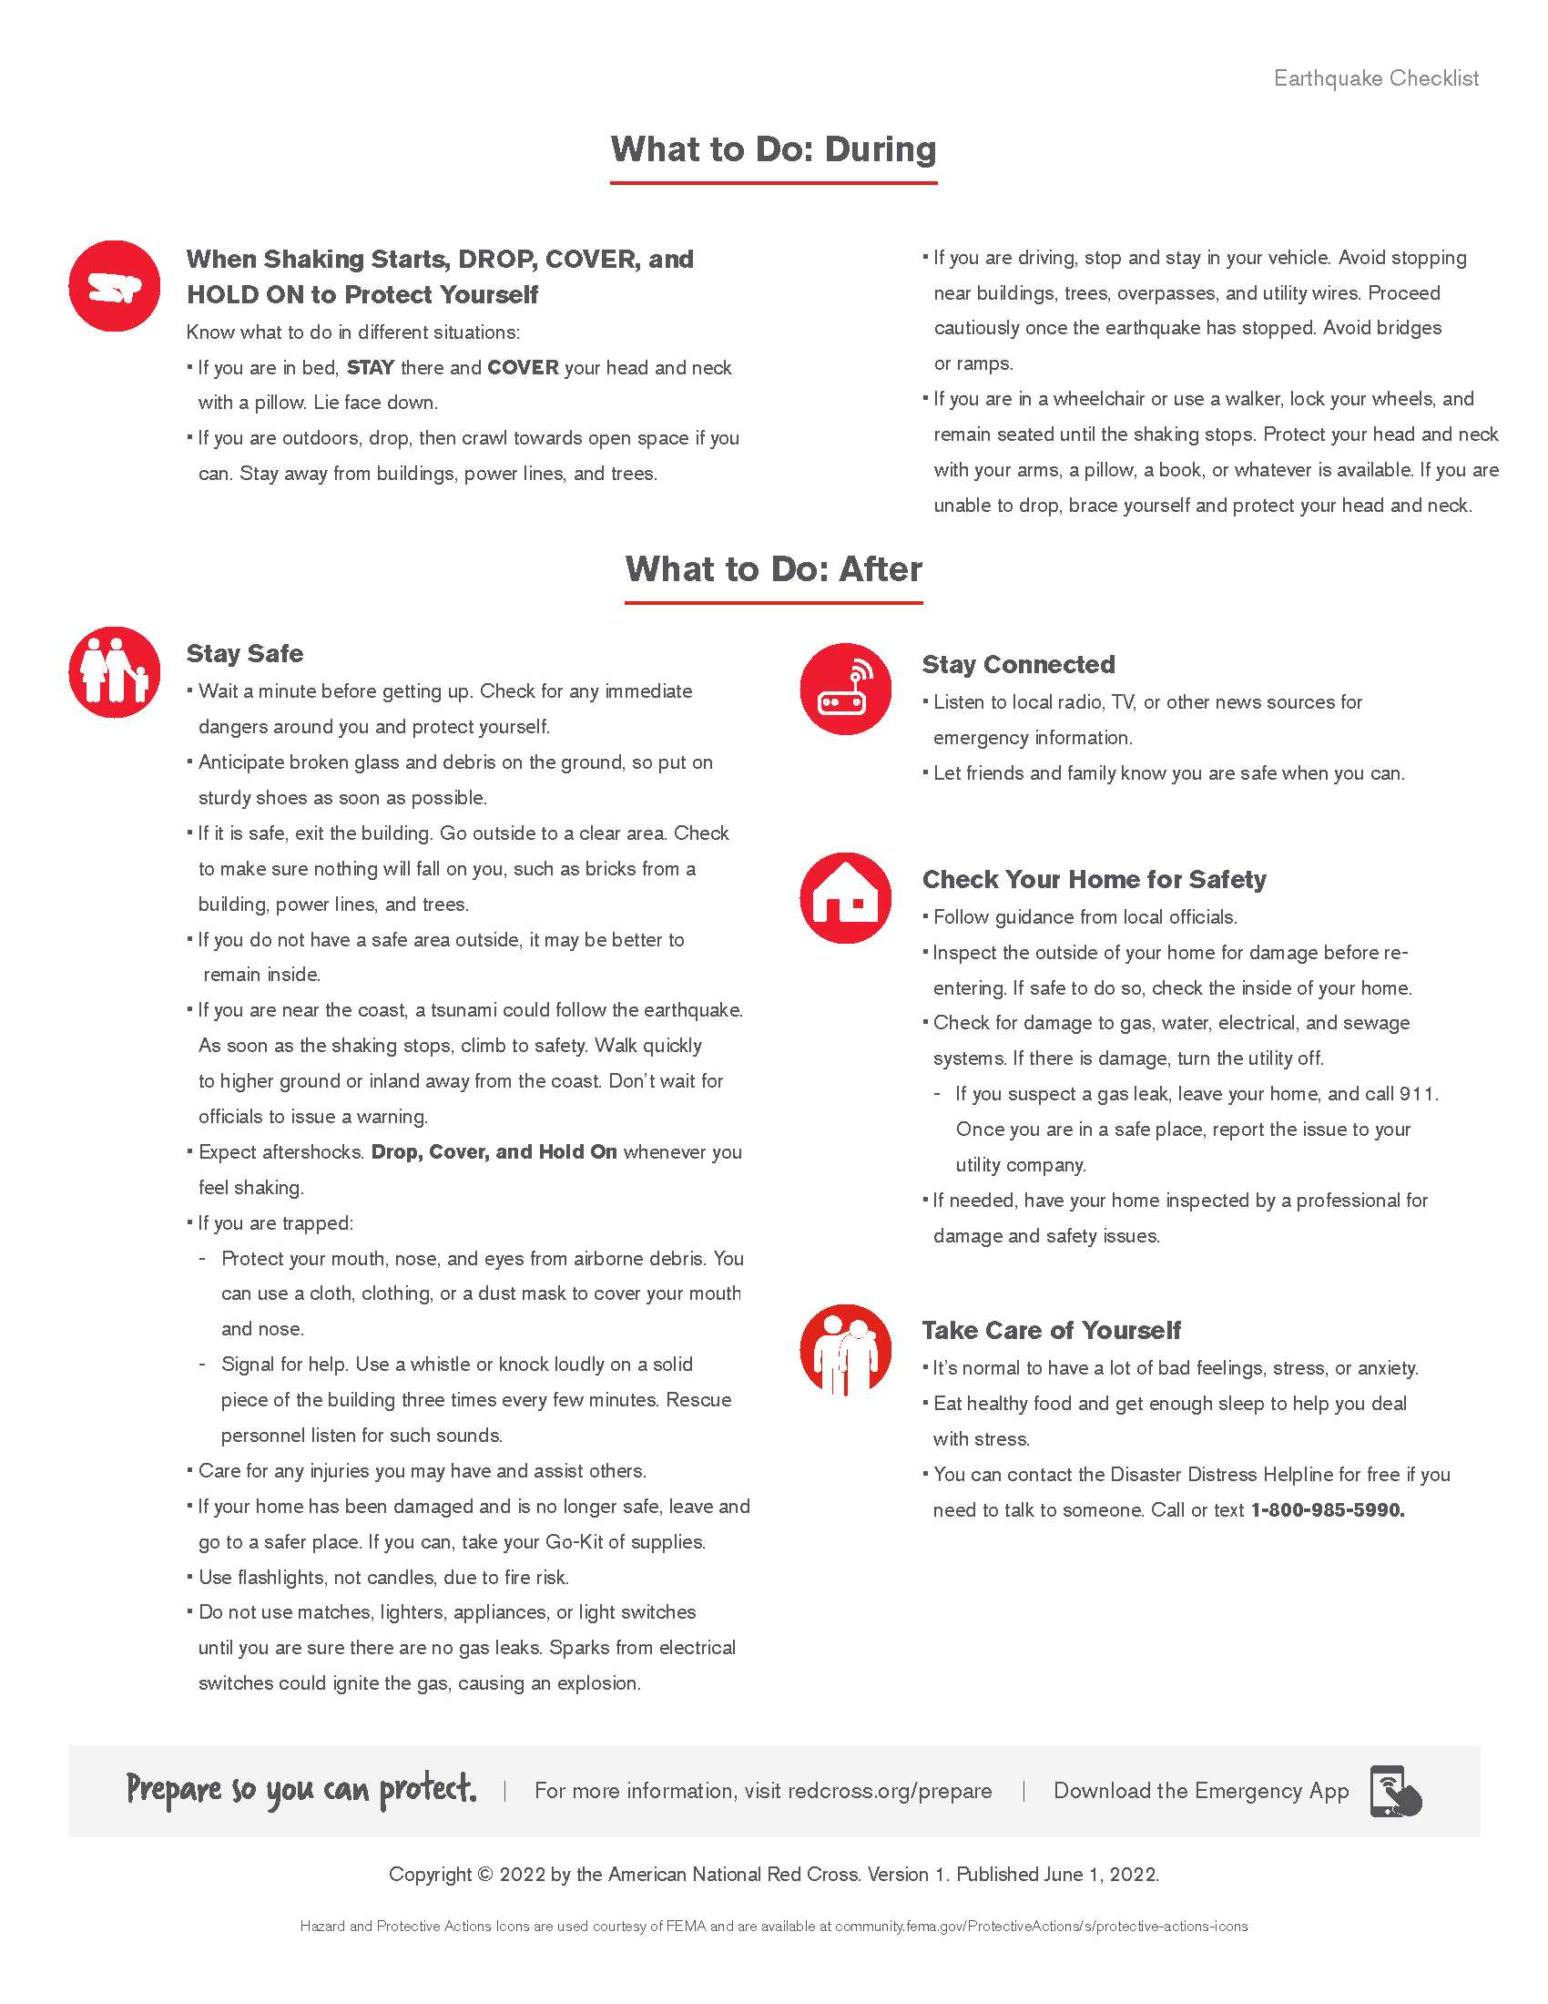

Conduct your own work area inspection. For more information about any concerns specific to your area (animal cages, chemicals, and/or valuable documents under water sprinklers, etc.), contact Risk Management at 805-662-6538. For more information about securing falling hazards, please contact your Department Safety Coordinator, Building Coordinator or Risk Management at (805) 662-6538.

**Hazardous Materials Procedures**

If you witness a hazardous material spill, evacuate the spill site and warn others to stay away. Call 911 if you believe the spill may be life threatening. If you can determine that the spill is not life threatening, follow the procedures outlined below.

If you are a hazardous material user(s), your supervisor should train you on the proper use and storage of such materials. This training should include hazard information, proper procedures for preventing spills and emergency procedures when spills occur, by way of a Safety Data Sheet (SDS).

If, as a user, you spill hazardous material(s) in your work area, follow the procedures below. If the spill of hazardous materials is outside the building, seek directions from the Fire Department while maintaining a safe distance from the spill and proceed as follows:

* Leave the area of the spill first and proceed to a safe location nearby. Then assess if you have the proper training and protective gear to clean up the spill

If you are able to clean up the spill, follow proper cleanup procedures and use proper personal protection. Manage the generated waste as appropriate. Consult your supervisor if necessary

Isolate the spill area to keep everyone away and post signs as necessary If you require assistance to clean up the spill call:

Environmental Health Hazardous Waste (805-654-2813)

If you suspect or witness a release of a hazardous material to the environment (air, water or ground) call Security (805-654-2931 or 805-654-2345) or the local law enforcement agency (911).

For additional information, refer to the Hazardous Materials Management policy and the Hazardous Material Abatement Program policy in the Administrative Manual, Chapter IX.

**Natural Gas Leak**

If you smell natural gas proceed as follows:

* Cease all operations immediately
* Do not switch lights on or off
* Notify Security (805-654–2931 or 805-654-2345) or GSA Maintenance (805-654–3878) from a safe location
* Evacuate as soon as possible (see "General Evacuation Procedures")

**Steam Line Failure**

In the event of a steam line failure:

Notify GSA Maintenance (805-654-3878), Security (805-654-2931 or 805-654-2345), or the local Law Enforcement Agency (911) and evacuate as soon as possible (see "General Evacuation Procedures").

**Training and Documentation**

Training is an integral part of the safety program for your building. It is the responsibility of each department to ensure all their employees are trained on the emergency procedures for the building(s) that they occupy. It is the responsibility of the occupant to become familiar with the emergency procedures, to know evacuation routes and emergency assembly areas and to attend training(s) given by their department.

Other training recommended for building occupants is CPR, first aid and fire extinguisher training. For information on CPR, first aid training and fire extinguisher training call Risk Management at 805-662-6538.

**Drills**

Building evacuation drills should be conducted at least once a year. If your building is scheduled to have a drill, the Building Coordinator is responsible for conducting the drill and documenting it. The GSA Special Services Division can help you in your planning (See policy IV (B)-11).

WORKPLACE SECURITY

**GENERAL INFORMATION   
Program Summary**

The GSA security program primarily focuses the safety and security of building occupants, assets, and information.

**Duties and Responsibilities**

Individual Employees

The primary responsibility for the safety of employees rests with each individual employee. The County can help with plans, technology, and training but each employee has to contribute. Employees must:

* Recognize and report suspicious persons/events: While violence doesn’t happen very often, other types of crime, such as theft, occur frequently
* Report safety and security concerns to supervisor(s)
* Maintain personal safety: In an emergency, employees should keep themselves safe so they can report the emergency and alert other employees
* Maintain workplace physical security: Each employee should assume responsibility for reporting malfunctions in door locks or equipment, making sure locked doors close behind them, and not letting anyone ‘tailgate/piggyback’ behind them when entering a secure area. Wear your County issued employee identification badge when at work

**EDUCATION, TRAINING, AND AWARENESS**

**County-Sponsored Training**

The County of Ventura Administrative Policy Manual, Policy No. Chapter IV (B)-2, establishes security training standards and guidelines. It requires that all employees be educated on proper workplace practices. It is provided to every new employee. Refresher training is required every four years.

Topics covered include Security Awareness, Workplace Violence, Computer and Network Security, Bomb Threat Response, and Mail Handling. Contact your supervisor, Human Resources, or GSA Security for training opportunities.

**Parking Lot Safety**

Special Instructions for Employees

To ensure convenient and safe parking, implement the following practices:

* Park only in a well-lit, highly visible location and report non-working lights to maintenance
* When you anticipate working past daylight hours, move your car during the day to improve its location
* In an emergency dial 911
* Lock your doors and roll up all windows
* Upon your return, scan the area around your vehicle as you approach it
* Return to your place of work if anyone looks or acts suspicious. Call the local law enforcement agency and the SCC to notify them of any suspicious activity
* Arrange a buddy system with a coworker if concerned about safely returning to your vehicle
* If necessary, call SCC and request an escort. Security personnel are available 24 hours a day, every day
* Park in higher traffic areas of the lot, if possible
* As you approach your vehicle, have your key(s) in hand ready to unlock the door. Avoid standing at your vehicle and digging through your purse or pocket(s) for your key

Please note that County policy regarding parking regulations and control can be found in the Administrative Manual Policy No. Chapter III – 2 entitled “PARKING AND CITATIONS AT THE GOVERNMENT CENTER.”

**PERSONNEL REQUIREMENTS**

**Hiring and Terminations**

Coordinate pre-hiring screening with Human Resources to ensure screening measures are adequate and confirm to applicable laws and policies.

New employees, including contractors, should be briefed on emergency evacuations procedures and their personal security obligations when first joining the County. New employees should receive copies of any currently applicable security policies and procedures, such as those that relate to the protection of confidential information and the use of computer equipment.

When an employee leaves, measures should be in place to retrieve county property, such as ID Badge, files, PCs, cellular phones, vehicles, credit cards, and any money advances.

The department personnel office will inform the GSA Security Operations Manager about any employee who is terminated who exhibits any tendencies toward violence, expresses an extreme dislike for a supervisor and/or coworker, or any combination thereof. The department head shall decide whether keyed door locks should be changed. The notification should be made in advance when possible.

**ID Badges**

Identification badges are issued to all County employees, contractors, and approved vendors and are to be worn at all times when working on County premises. It is against County policy to share them or assist others in accessing County property with them unless otherwise indicated in the Administrative Manual.

Badges are issued by GSA Security Operations located in the GSA Service Building at the Ventura County Government Center. If your badge is lost, stolen, or misplaced, immediately notify GSA Security at 805-654-2931 and your supervisor. Upon termination of employment, you are required to return your badge to GSA Security Services.

Policy and procedures for an employee identification badge are detailed in the Administrative Manual, Policy No. Chapter IV (B) – 5 EMPLOYEE IDENTIFICATION BADGE.

**Digital Access Card**

Each department/agencyis responsible for approving door access assignments.This person is typically listed on the GSA, Authorization Form.

Policy and procedures for digital access cards are detailed in the Administrative Manual, Policy No. Chapter IV (B) – 8 entitled DIGITAL ACCESS CARD READER SYSTEM. This policy provides instructions on how to use the card and an explanation of the security badge color coded system.

The document below should be filled out in the event an access card is lost or stolen. This document can be found on the GSA website under Security and Special Services.

**DELIVERIES**

If your department receives deliveries, procedures should be established to authenticate the person’s identity and authorization for access.

Because the requester and the receiver may differ, all deliveries shall be confirmed by the receiving department before the vendor is allowed to deliver a service or product.

Methods to confirm the delivery include contacting the contract administrator or the vendor’s home office and verifying the delivery contents, approximate delivery time, and name of delivery person scheduled to make the delivery. If this information is unknown to the employee or county, decline the delivery. If anything about the attempted delivery seems suspicious, notify Security.

Every vendor employee or volunteer must display a County of Ventura identification badge while working on County premises. To obtain one, the individual must undergo a background investigation. Departments are responsible for ensuring that these requirements are met. For assistance in obtaining a government sponsored background check, contact the GSA Security department at (805) 654-2051.

**PHYSICAL SECURITY**

**Business hours for County offices**

Physical Security is the ability to control physical access to the workplace and to specific locations inside the workplace. This includes controlling unauthorized access during non– business hours and denying access to a dangerous person when employees are present.

In accordance with the Administrative Manual, Policy No. Chapter IV (A) 1 – entitled “BUSINESS HOURS FOR COUNTY OFFICES,” the hours for transactions are from 8:00 a.m. to 5:00 p.m. on business days. Special provisions for the Hall of Justice and Hall of Administration can be found in the Administrative Manual, Policy No. Chapter IV (B) – 6 entitled “AFTERHOURS ACCESS TO HALL OF ADMINISTRATION AND HALL OF JUSTICE.”

**Exterior Doors**

Most exterior doors on buildings at the County are substantial enough to deny quick entry by force. Most have “panic bars” or devices that allow a person to exit easily in an emergency. Notify GSA Maintenance Dispatch Services at (805) 654-3878 immediately if locking hardware becomes loose or door closing devices or latches aren’t working correctly. Keep all employee entrances locked at all times. All doors shall be locked after closing. Do not allow people to “piggyback” through a locked door.

**Interior Doors**

Interior doors that are solid core are the most secure, but often they are designed with clear or frosted glass panels. The most common problems are unlocked office doors or doors left open. When leaving your office, always lock the door, even if you will only be gone for a moment. Doors to unoccupied rooms are to be locked when not in use. As a refuge from a dangerous person there (if at all possible) should be enough “Safe” rooms for employees to seek shelter in place during an emergency.

Specifics regarding installation and repair of locks can be found in Administrative Manual, Policy No. Chapter IV (B) – 7, entitled “KEY AND LOCK CONTROL.”

**Lighting System**

Lighting is part of the overall Security Program. Applications include:

* Perimeter
* Entry way
* Loading docks
* Standoff zone for unscreened persons or vehicles
* Parking lots and garages

**Windows**

Windows should not open far enough for a person to enter or to reach through far enough to reach the latch. Windows must be closed before leaving the workplace.

**Locks and Keys (including key cards)**

A primary area of concern when using lock/key security is the unaccounted for issuance of keys and unauthorized key copying. The issuance of master keys should be on a strict need-to-have basis and NOT for convenience. The loss or compromise of a master key can be devastating to an agency/department’s budget. We recommend that only a very few master keys be issued. A rigorous method of key control is an important part of physical security.

Responsibilities

The Key Control Manager is responsible for issuance of all keys to any doors, lockers or drawers in his/her office. He/she shall ensure that a record is maintained of all keys issued.

* An employee is responsible for any and all keys issued to them
* Employees will NOT loan or transfer their keys to any other individual
* Employees are not to unlock doors for others unless directed by the department management. Authorized card key holders are not allowed to let anyone into a building after business hours under normal circumstances. The only exception is for public safety personnel if required for an emergency
* Keys will be returned to the Agency/Department Key Control Manager (whichever is applicable) when an employee terminates or transfers within the County
* Unauthorized people or any suspicious activities are to be reported to the SCC immediately
* Any County keys found should be turned in to GSA Security

Each department is responsible for keys issued within the department. It is recommended that each department maintain its own internal, written inventory of keys and only issue keys to personnel that need access to the facility. An inventory of all Masters/Sub-masters issued is maintained in the GSA Security Office for GSA-maintained buildings.

Unauthorized Duplicating/Replacing Keys

Duplicating or replacing County-owned building keys through an agency, company, or private business other than the County of Ventura, is *NOT ALLOWED* and is a breach of this key policy. When this violation has been discovered, the appropriate Agency will be notified for appropriate action.

Returning Keys

Prior to leaving the County, all keys *MUST BE RETURNED* to the office Key Control Manager. It is the responsibility of the department to retrieve all keys from departing employees.

Employees transferring from one location to another within the County *ARE REQUIRED TO RETURN* their present keys. Employees can request keys for their new location by submitting a Key Request form through the proper channels.

Lost or Stolen Keys

All lost/stolen keys *MUST BE REPORTED IMMEDIATELY* to your department and the GSA Security Office.

To report a lost or stolen key, a memorandum should be generated stating all facts about the incident. A copy of the memorandum will be sent to the Security Operations Manager to ensure immediate concerns are addressed in the case of a stolen key. The department head shall decide whether a new lock should be installed.

**Security Alarm(s)**

Some workplaces may be equipped with security alarms. Selected employees shall be trained in the activation of alarms for the work area and methods of response. It is the responsibility of department management to administer training regarding the location and manner of operation of each device.

**RESPONSE TO VIOLENCE (Workplace Violence)**

The County of Ventura is dedicated to the prevention of all levels of violence and is committed to reducing the occurrence and impact of violence in the workplace. It is essential that we all do our part in keeping the County work spaces a safe and productive place for all to work and visit. It is important that we: Stay observant and aware of our surroundings at all times. Display our County of Ventura ID badge while working on County premises and be aware of anyone in a restricted area without a valid ID badge. Keep locking doors closed to keep unauthorized persons out of restricted areas; and, be cognizant of behaviors that may lead to potentially violent situations. In the event of an emergency please call 911 and for other non-life-threatening emergencies, please contact GSA Security Center @ 805 654-2931. Should you observe any of the following behaviors, immediately report them to your supervisor and/or Human Resources:

•          Fascination with weaponry and/or acts of violence

•          Verbal, nonverbal or written threats or intimidation

•          Expression of hopelessness

* Emotionally unstable behaviors

•          Harassing, stalking, or showing undue focus on another person

•          Verbal abuse including offensive, profane and vulgar language

•          Physical assault upon oneself or another person

•          Physically aggressive acts, such as shaking fists at another person, kicking or pounding

desks, punching a wall, angrily jumping up and down, screaming at others

**In any emergency, do not hesitate to call 911.**

For additional information, see the County of Ventura Security Awareness Course Materials. They can be obtained via the Human Resources Office.

**Workplace Shooting**

We all must know how to respond in the unlikely event we are confronted with an active threat. Please take a moment and familiarize yourself with your work spaces and identify your best escape routes and hiding places. When confronted with an active threat there are three steps you can take to help protect yourself. They are:

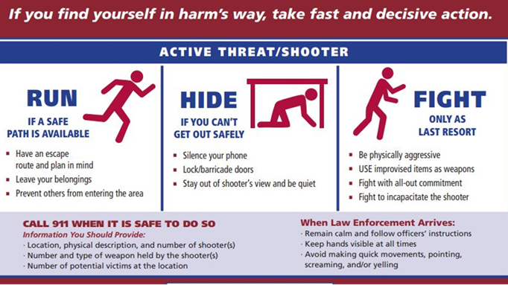

**Safe Rooms**

The Safe Rooms should be used whenever you make the decision to protect yourself from danger by sheltering in place rather than evacuating. Safe rooms should be:

* Located inside a work area
* Accessible from all parts of the work area
* Have a solid core door or a door with small glass panels, a way to restrict vision from the outside, a lock, and telephone

**Explosion or Bomb Threat Procedures/Suspicious Mail Packages/Suspicious Activity or Persons**

In the events of a threat, notify 911 and then GSA Security

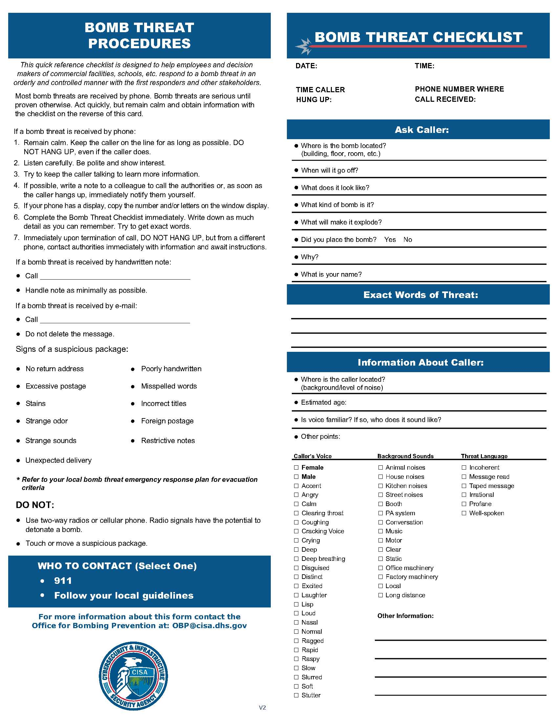

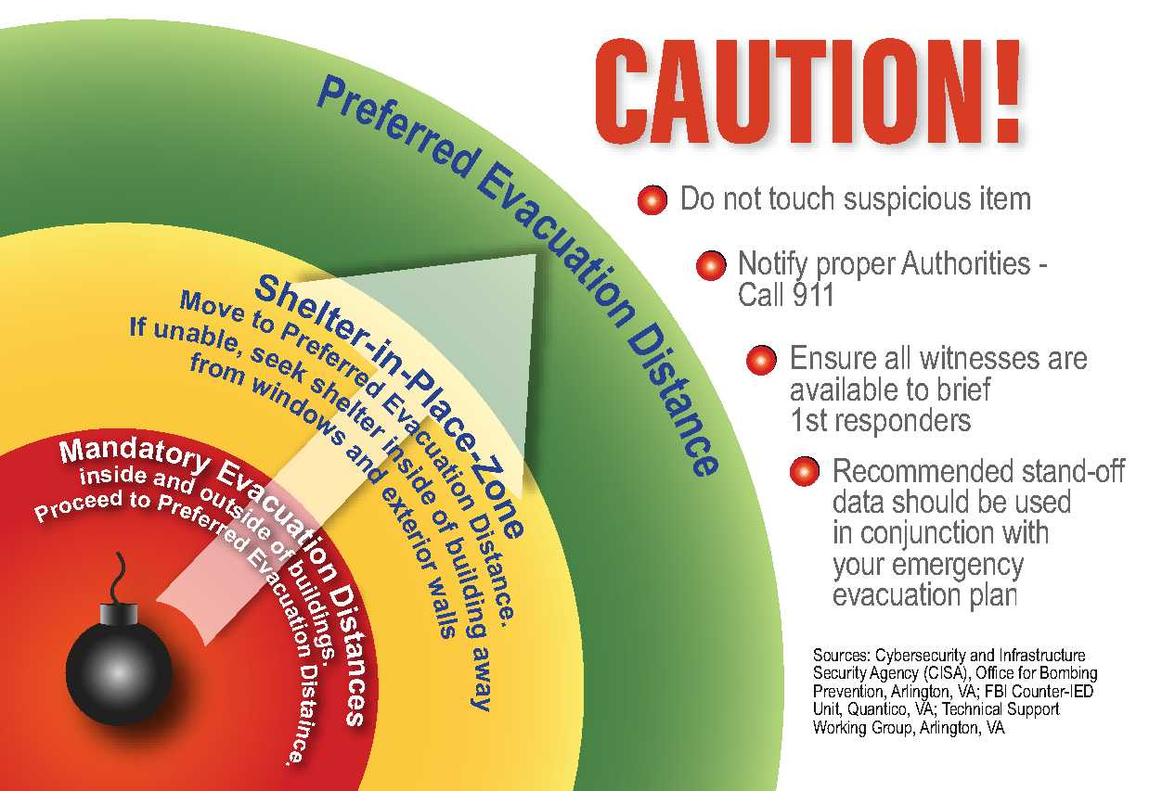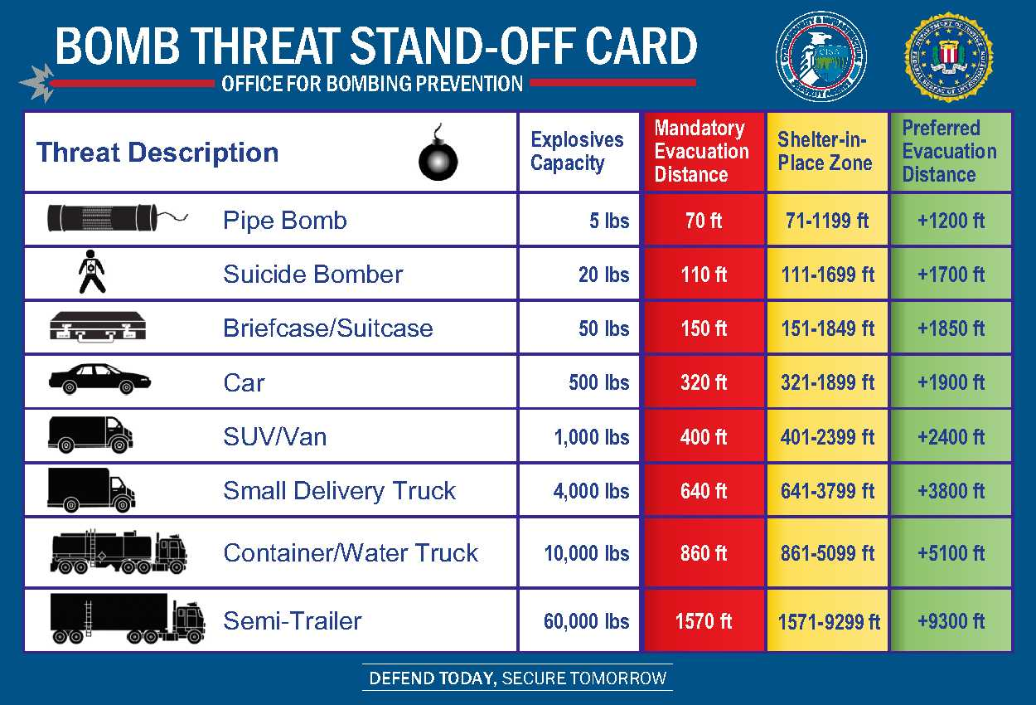

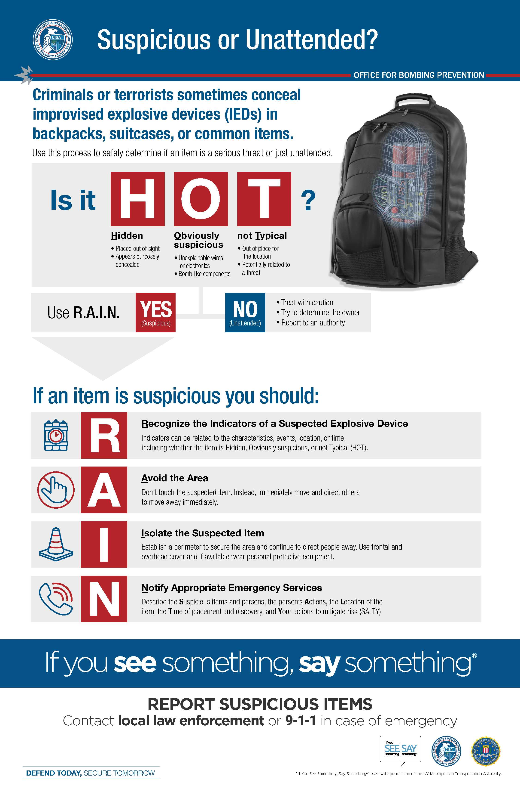

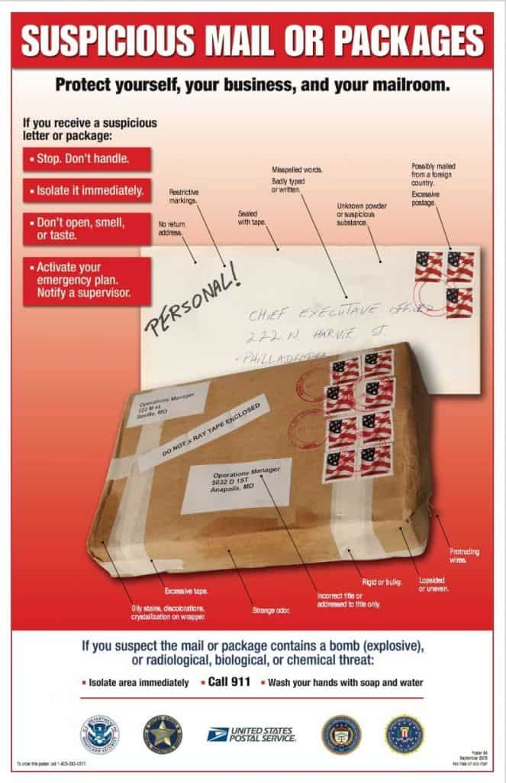

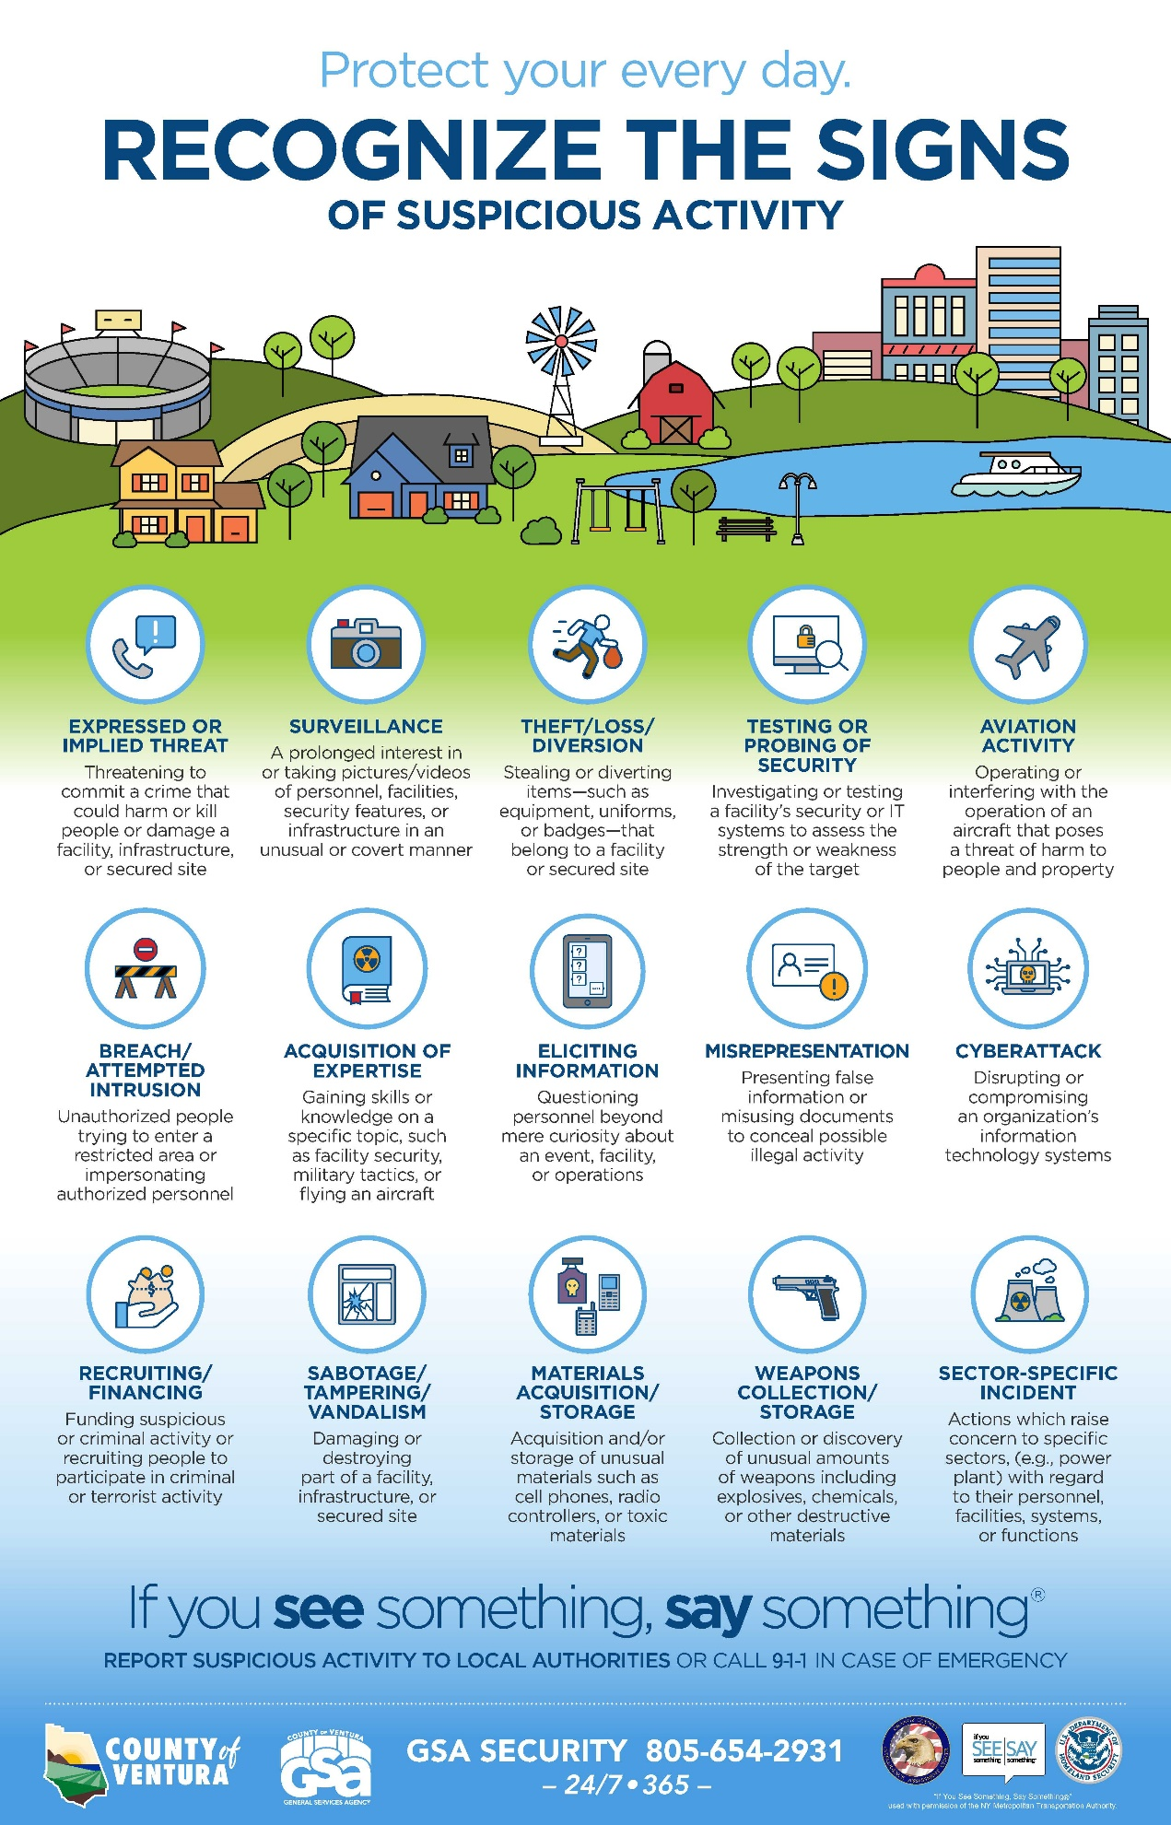

**Office Security**

Document Protection

* Do not leave work papers on your desk, especially at night or on weekends, and remove from the walls any confidential maps, drawings, or schematics that are not in use
* Keep filing cabinets and closets locked when they are not being regularly accessed
* Be alert for unescorted strangers in your work area, and challenge their right to be there. If the answer given is unsatisfactory, notify a supervisor or a security officer
* Don’t reveal to unidentified telephone callers or visitors the comings and goings of County officials or of visits and meetings
* Unless instructed otherwise, don’t give out home telephone numbers, addresses, or personal information concerning fellow employees and County officials. If a caller expresses an important need to talk with an employee who is not in the office, call the employee and pass on the caller’s number or obtain permission to give the caller the employee’s contact number
* Be careful not to leave sensitive information on whiteboards

Copier, printer, fax, and scanner devices store information in the memory until they need to overwrite the data to accommodate the storage of new data. This information is retrievable.

Destruction and Disposal

The improper disposal of such information is a security concern. There are individuals (dumpster divers) who search dumpsters in hopes of finding information they can exploit for unethical and unlawful purposes. They seek information such as business proposals, security plans, passwords, employee records, union negotiation strategies, hard drives, employee exams, etc. Don’t give them anything to find.

To reduce the threat or loss of confidential information to dumpster divers the following is recommended:

* Never put confidential information into trash cans
* Detroy/shred confidential information onsite prior to disposal

**Restraining Order**

Although restraining orders are often domestic in origin, they can and often do impact the health and safety of employees and members of the public. See Policy No. IV (B) – 12 ‘Restraining Order Policy (GSA)’.

**Public Demonstration Procedures**

Most demonstrations are peaceful and should not disrupt normal business operations. People not involved need to avoid provoking or obstructing demonstrators. Should a disturbance occur, call the local law enforcement at 911 or Security at (805) 654-2931 or (805) 654-2345. If a disturbance seems to be threatening to the occupants of the building, report it immediately to the local law enforcement and take the following actions:

* Alert all persons in the area of the situation
* Lock all doors and windows
* Close blinds to prevent flying glass

**APPENDIX A**

**Building Emergency Plan/Roles**

Building occupants are responsible to know their building emergency plans. If you have questions, consult your Department Safety Coordinator or Safety Committee representative. Keep the following in mind as you read through this document:

Pull alarm locations, evacuation routes, exit points and your designated reporting area (roll call will be taken after evacuation of the building).

When and how to evacuate the building.

Locations of emergency supplies and materials that may be needed in an emergency such as fire extinguishers and first aid kits.

Proper procedures for notifying people with disabilities about an emergency situation in the building or work area and obtaining evacuation chairs.

Fire Hazards.

Potential exposure to hazardous materials or processes in and around the work area, as well as any means of protecting yourself in the event of an emergency.

Additional responsibilities for Area Assembly Coordinator (AAC) or Evacuation Guide.

**The below documents should be used as part of the evacuation plan. These documents should be completed and kept current.**

***Designation of Staff to Fulfill Specific Evacuation Roles***

For the one-year period commencing: Click here to enter a date.

Agency: Click here to enter text.

Evacuation Manager: Click here to enter text.

Evacuation Manager (Alternate): Click here to enter text.

Evacuation Guide (may be more than one): Click here to enter text.

Evacuation Guide (Alternate): Click here to enter text.

Assembly Area Coordinator: Click here to enter text.

Assembly Area Coordinator (Alternate): Click here to enter text.

Assembly Area Runner: Click here to enter text.

Assembly Area Runner (Alternate): Click here to enter text.

Designation of Emergency Assembly Areas

For the one-year period commencing: Click here to enter a date.   
Emergency Assembly Area: Click here to enter text.

(Department Location): Click here to enter text.

Responsibilities Click here to enter text.

Evacuation Manager

* Instruct employees to evacuate and, as appropriate, which exits to use/avoid.
* Monitor the evacuation to confirm that employees leave the building quickly and safely.
* Assist with directing visitors and others who need help to/through the exits.

Evacuation Guide

* Sweep assigned public areas (lobbies, hallways and restrooms) to instruct visitors to evacuate calmly.
* Sweep vacated offices to ensure full evacuation.
* Shut down designated equipment (If needed in your space).
* Secure critical areas.

Assembly Area Coordinator

* Exit the building.
* Proceed to the designated emergency assembly area for their work unit.
* Designate supervisors or other reliable staff members to assist in accounting for employees in each section of the Department/Division/Unit evacuated to your emergency assembly area. Attendance Rosters or Sign-In/Out sheets are valuable

tools in counting present/absent/missing employees during the evacuation.

Assembly Area Runner

* Exit the building.
* Proceed to the designated emergency assembly area for their work unit.
* Assist the Assembly Area Coordinator in completing the Employee Tally by compiling

the following information (see Sample Forms):

* Number of employees present and accounted for:
* Number of employees absent and accounted for:
* Number of employees unaccounted for:
* Names and possible location of unaccounted for employees:
* Names of employees from other Departments/Divisions located in the building that are now gathered with our Assembly Group:
* Visitors from other Departments/Divisions not in our building and/or members of the public that are now gathered with our Assembly Group:
* Injuries sustained during or as a result of the evacuation/emergency:

**The Emergency Assebly Tally Sheet should be used anytime there is an evacuation. Completed sheets should be provided to emergency or security personal on scene.**

**Emergency Assembly Area - Employee Tally**

Once employees have gathered at your assembly site, a count should be taken. The following information should be reported back to the Incident Command Center.

Number of Employees assigned to Department/Division at this building? _____

Number of Employees present and accounted for is:

Number of Employees absent and accounted for is:

Number of Employees unaccounted for is:

Names and possible location of unaccounted for Employees:

Name Probable Location Name Probable Location

Names of Employees from **other** Departments/Divisions located in the building that are now gathered with our Assembly Group:

Name Dept/Division Name Name Dept/Division Name

Visitors from other Departments/Divisions not in our building and/or members of the public that are now assembled with our Assembly Group:

Injuries:

**Evacuation Evaluation Worksheet**

**Page ___ of ___**

**Building: Date of Evacuation:**

**Time of Evacuation:**

**Reason for Evacuation:**

**Department/Division: EvacuationManager:**

**Elapsed Time Record (Record the amount of time taken between the following steps during the evacuation)**

Incident Awareness/Alarm _____ minutes

Alarm/Employees Evacuated _____ minutes

Employees Evacuated/You Evacuate _____ minutes

You Evacuate/Employee Tally Sheet Received _____ minutes

Employee Tally Sheet Received _____ minutes

**Evaluation of Employee Response to Evacuation Excellent ___ Good/Fair ___ Poor___**

Did anyone need help exiting the building? Yes ___ No ___

If yes,what type of help was needed?

Who provided the help? Co-workers ____Fire/Law Enforcement Officials _____Other ___

What could be changed to avoid/improve situation in the   
future?

Did anyone refuse to leave the building? Yes ___ No ____

If yes, who?

Did anyone refuse to follow Evacuation Plan Orders? Yes ___ No ____

If yes, who?

Did anyone refuse to follow instruction from Assembly Area Coordinators? Yes ___ No ____

If yes, who?

What could be changed to avoid/improve the situation in the future?_

Did all building equipment (alarms, exit lights, elevator) function properly? Yes___ No____

If no, what equipment failed? Where is it located?

Other Information:

**APPENDIX B**

**EVACUATION GUIDELINES FOR PEOPLE WITH DISABILITIES**

The following guidelines have been adopted by the County of Ventura to assist in planning for the evacuation of people with physical disabilities.

FOR ALL EMERGENCIES, AFTER AN EVACUATION HAS BEEN ORDERED:

* Evacuate people with disabilities if safe to do so.
* **DO NOT** use elevators, unless authorized to do so by law enforcement or fire personnel.
* If the situation is life threatening, call 911.
* Check on people with special needs during an evacuation. A "buddy system" is a good method where people with disabilities arrange for volunteers (co-workers) to alert them and assist them in an emergency.
* Attempt a rescue evacuation ONLY if you have had rescue training or the person is in immediate danger and cannot wait for professional assistance.
* Always ASK someone with a disability how you can help BEFORE attempting any rescue technique or giving assistance. Ask how he or she can best be assisted or moved and whether there are any special considerations or items that need to come with the person.

RESPONSES TO EMERGENCIES   
**Blindness or Visual Impairment**

Bomb Threat, Earthquake, Fire, Hazardous Material Releases and Power Outages:

* Give verbal instructions to advise about the safest route or direction by using compass directions, estimated distances and directional terms.
* **DO NOT** grasp a visually impaired person's arm. Ask if he or she would like to hold onto your arm as you exit, especially if there is debris or a crowd
* Give other verbal instructions or information (elevators cannot be used) **Deafness or Hearing Loss**

Bomb Threat, Earthquake, Fire, Hazardous Materials Releases and Power Outages:

* Get the attention of a person with a hearing disability by touch and eye contact. Clearly state the problem. Gestures and pointing are helpful, but be prepared to write a brief statement if the person does not seem to understand.
* Offer visual instructions to advise of the safest route or direction by pointing toward exits or evacuation maps.

**Mobility Impairment**

Bomb Threat, Earthquake, Fire, and Hazardous Material Releases:

* It may be necessary to help clear the exit route of debris (if possible) so that the person with a disability can move out or to a safer area.
* If people with mobility impairments cannot exit, they should move to a safer area (enclosed stairwells or an office with the door shut, which is a good distance from the hazard and from falling debris)

If you do not know the safer areas in your building, call GSA Maintenance (805-654– 3878) for a building survey:

* Notify law enforcement or fire personnel immediately about any people remaining in building and their locations.
* Law enforcement or fire personnel will decide safety issues, location of problem areas and, if necessary, evacuation procedures. The Fire Department may determine that it is safe to override the rule against using elevators.
* If people are in immediate danger and cannot be moved to a safer area, wait for assistance. It may be necessary to evacuate them using an evacuation chair or a carryout technique

Power Outages:

* If an outage occurs during the day, people with disabilities may choose to wait in the building for electricity to be restored. Moving near a window where there is natural light and access to a working telephone is suggested. During regular building hours, the Building Coordinators should be notified so they can advise emergency personnel of the situation
* If people would like to leave and an evacuation has been ordered, or if the outage occurs at night, call the GSA Security Control Center (805-654-2931 or 805-654-2345) to request evacuation assistance from the Fire Department.

**Emergency Evacuation of People with Disabilities**

Evacuating a disabled or injured person should be your last resort. You run the risk of injuring yourself and others during an evacuation attempt. Consider your options. Do not make an emergency situation worse.

Evacuations are difficult and uncomfortable for both the rescuer and the person being assisted. Some people have conditions that can be aggravated or triggered if they are moved incorrectly. Remember that environmental conditions, such as smoke, debris and/or loss of electricity will complicate evacuation efforts.

The following guidelines are general and may not apply in every situation:

* Occupants should be invited to volunteer ahead of time to assist disabled people in an emergency. If a volunteer is not available, designate someone who is willing to accept the responsibility in assisting
* Volunteers should obtain evacuation training on certain types of lifting techniques through Risk Management
* If available, two or more trained volunteers should conduct the evacuation
* **DO NOT** evacuate disabled people above the first floor in their wheelchairs. This is standard practice to ensure the safety of disabled people and volunteers. Wheelchairs will be evacuated later if possible
* Always ASK the disabled person how you can help BEFORE attempting any rescue technique or giving assistance. Ask how they can best be assisted or moved. Ask if there are any special considerations or items that need to be gathered before the evacuation
* Before attempting an evacuation, the volunteer rescuers and the disabled evacuee should discuss the lifting process along with the ultimate destination
* Proper lifting techniques (bending the knees, keeping the back straight, holding the person close before lifting, using leg muscles to lift, etc.) should be used to avoid injury to a rescuer’s back. Ask the evacuee if an evacuation chair or similar device is being considered as an aid in an evacuation. If so, ask permission to use it. When using such devices, make sure the person is secured properly. Be careful on stairs and rest at landings if necessary.
* Certain lifts may need to be modified depending on the person's disabilities

Prepare occupants in your building ahead of time for emergency evacuations. Know your building occupants. Train staff to be aware of the needs of people with disabilities and to know how best to offer assistance. Hold evacuation drills in which occupants participate. Evaluate drills are important to identify problem areas that need improvement. Evacuation plans must cover regular working hours, after hours and weekends.

Everyone needs to take responsibility for preparing for emergencies. People with disabilities should consider what they would do in the event of emergency and make additional preparations if needed. "Emergency Guidelines for People with Disabilities" is available in your Evacuation Procedure Manual (EPM, Section 8) or from your Building Coordinator and Department Safety Coordinator.

If you have any questions or need additional information, contact any one of the organizations listed below:

* Evacuation Policies GSA Special Services/Security
* Employee Disability Issues Building Coordinator, ADA Coordinator or Representative
* Fire Regulations Ventura County Fire Department

**APPENDIX C (Evacuation and Assembly Area Maps)**

Click here to enter text.

Click here to enter text.

Click here to enter text.

**APPENDIX D (Additional site/department specific information)**

Click here to enter text.

Click here to enter text.

Click here to enter text.

Click here to enter text.

Click here to enter text.

Click here to enter text.

Click here to enter text.

Click here to enter text.

Click here to enter text.

Click here to enter text.