HEMP ORDINANCES IN VENTURA COUNTY
In April 2019, the California Department of Food and Agriculture adopted regulations to facilitate the registration of industrial hemp growers pursuant to requirements in Chapter 24 of the Food and Agriculture Code of California as passed by the California Legislature and signed into law by the Governor. These requirements specified that registrations must be completed through the county agricultural commissioners throughout the State.
In the first year there were 54 applicants to grow hemp in Ventura County. There were 134 sites and 3,800 acres registered beginning in May 2019.
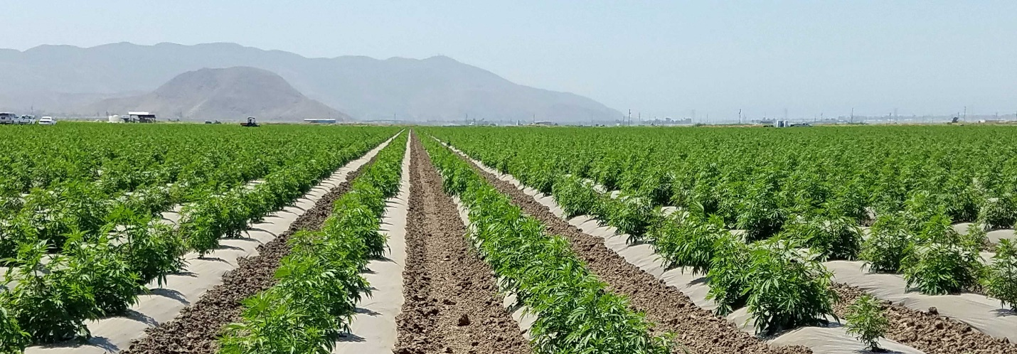
In August of 2019, the Agricultural Commissioner’s Office began to receive numerous complaints about the smell, and the potential smell of industrial hemp plantings. Many of these complaints were centered around the Tierra Rejada Valley and Camarillo from the Leisure Village area. These complaints continued and increased through the month of November when the crops were harvested and removed.
On November 19, the Ventura County Board of Supervisors held a special meeting in Moorpark which concluded with a report from the Agricultural Commissioner about industrial hemp in Ventura County. Dozens of residents and growers provided comments about the detriments, particularly the odor, and benefits of industrial hemp during that meeting.
On December 10, 2019, the Board held another hearing on the County’s authority to cease registrations to growers of industrial hemp or to temporarily prohibit the cultivation of industrial hemp.
At the same meeting the Board conducted a public hearing addressing the planting of hemp in all unincorporated areas of the County. At the conclusion of the meeting, the Board requested staff to develop an urgency ordinance to ban industrial hemp planting within ½ mile of sensitive receptors in areas zoned residential in cities and unincorporated areas, and near schools. They further directed staff to return with recommendations for an ordinance establishing schedules or “windows” for planting industrial hemp in the unincorporated area and exempting from regulation industrial hemp in greenhouses with adequate filtration systems to control odor, and nurseries where propagative hemp material is grown.
On January 14, 2020, the Board adopted Urgency Ordinance No. 4558, banning industrial hemp planting within ½ mile of sensitive residential zoned areas in cities and unincorporated areas, and near schools. The urgency ordinance exempted only production of nonflowering propagative plants within the ½ mile setback area from sensitive receptors.
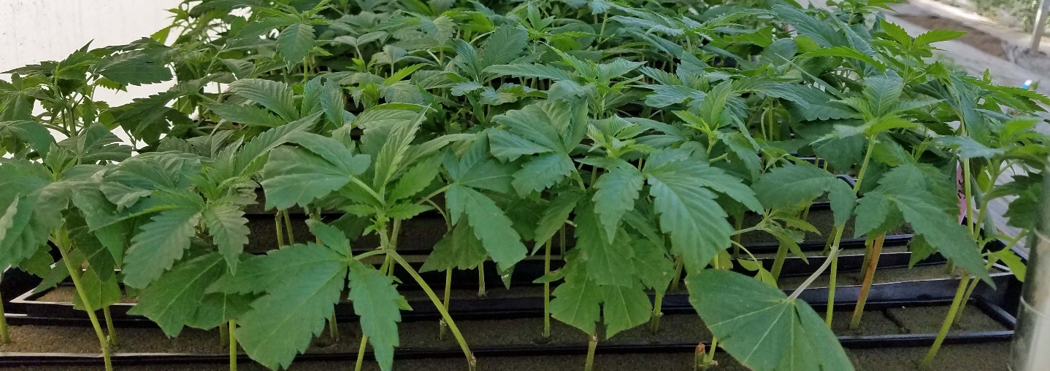
On February 25, 2020, the Board extended Urgency Ordinance No 4558 for up to 10 months and 15 days. They further instructed the Agricultural Commissioner to develop language for a regular land use ordinance to regulate industrial hemp to be reviewed by the County Planning Commission and then returned to the Board for adoption. This was expected to take approximately three to four months to draft ordinance language, review, hold hearings and to obtain approval.
Initial draft language was posted on the Agricultural Commissioner’s website requesting public input through an email submission process on March 6, 2020. Based on input received the Agricultural Commissioner is now submitting revised draft language and requesting additional input from interested parties.

